HW1 Part (1) Plotting Graphs:

**Plot1: Boxplots for at least three variables on the same plot**

Using ggplot2

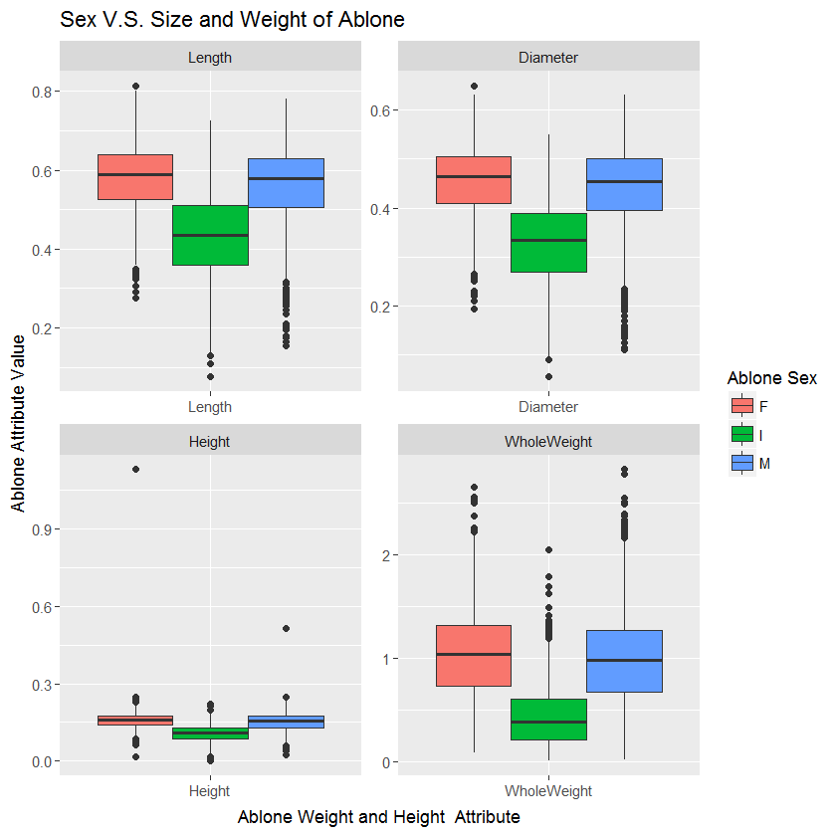

Using Base R

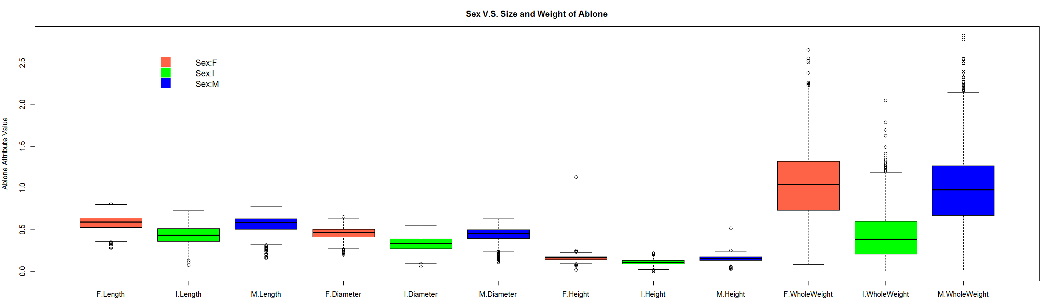

**Plot 2: Histogram with normal curve**

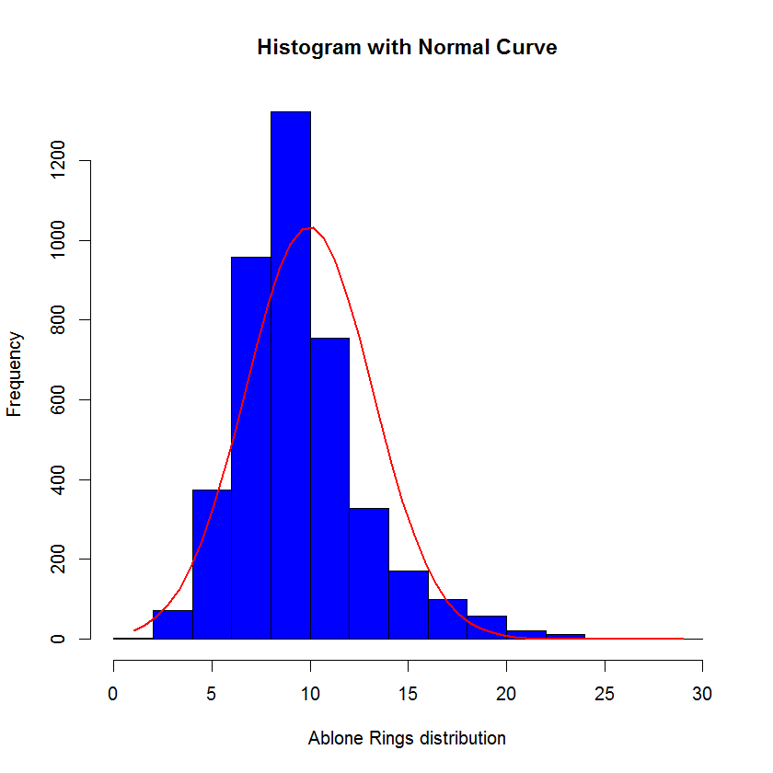

**Plot 3: Scatterplot between two variables**

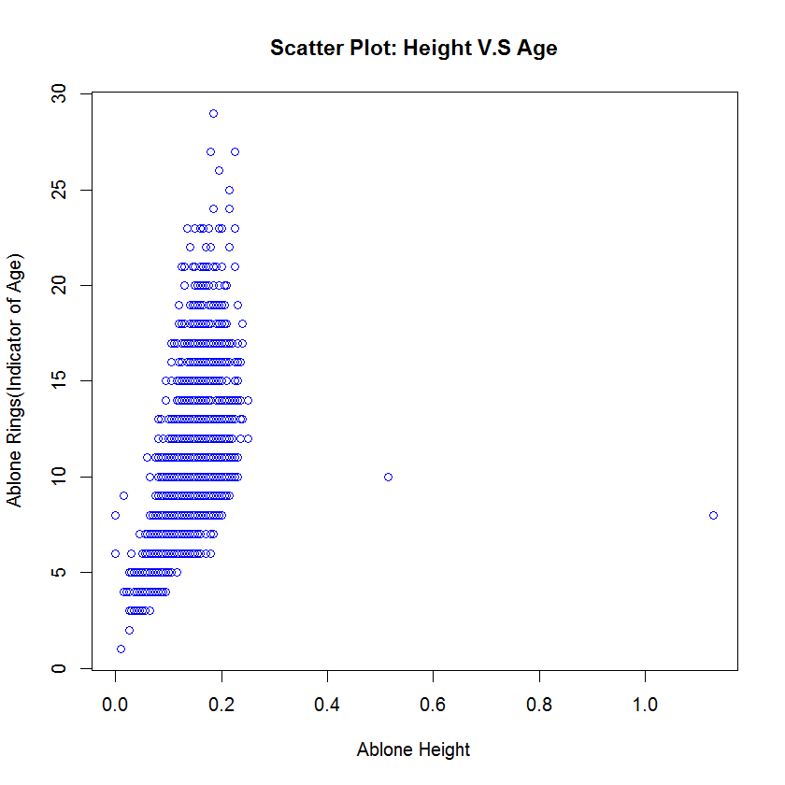

**Plot 4 : Multiple Bar Graph**

